DQL

- select * from Book

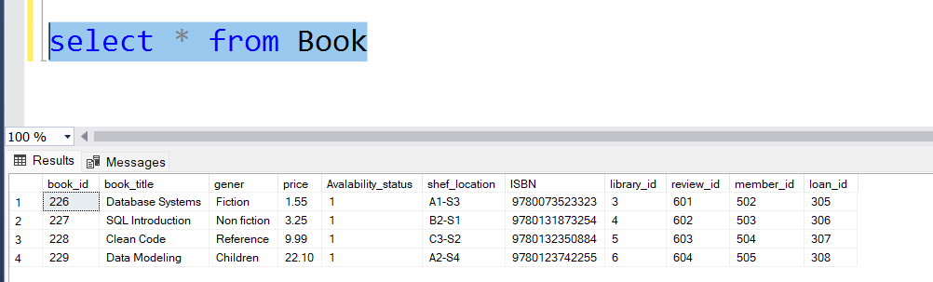

- SELECT book_title, gener , Avalability_status FROM Book

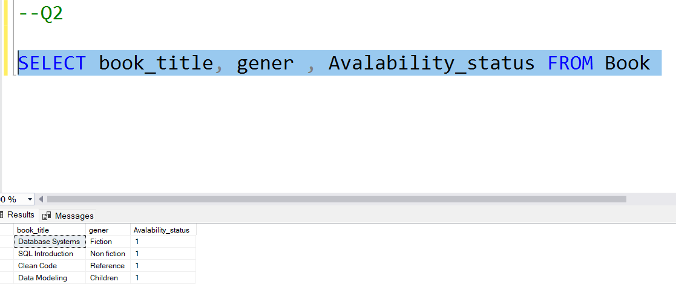

- select FullName, member_Email , Mempership, Start_date FROM Member

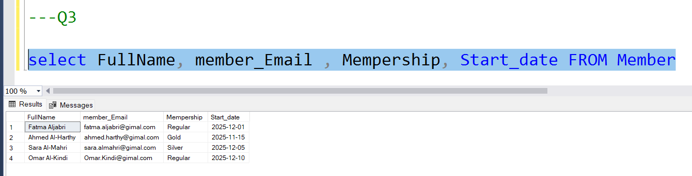

- select book_title , price AS BookPrice From Book
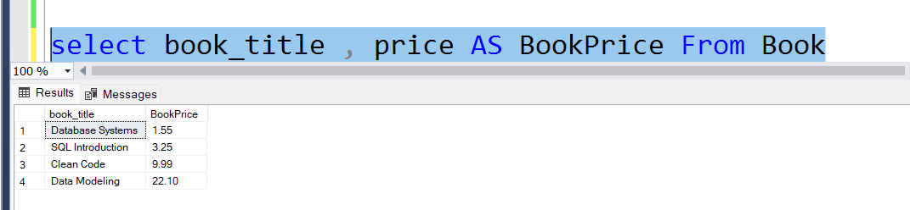

- select book_title ,price AS BookPrice
FROM Book
where price > 250

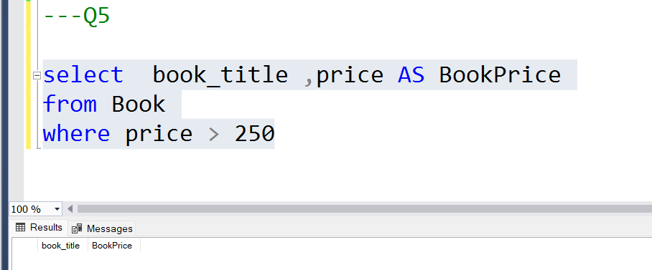

- select FullName , Start_date
from Member
where Start_date > '2023'

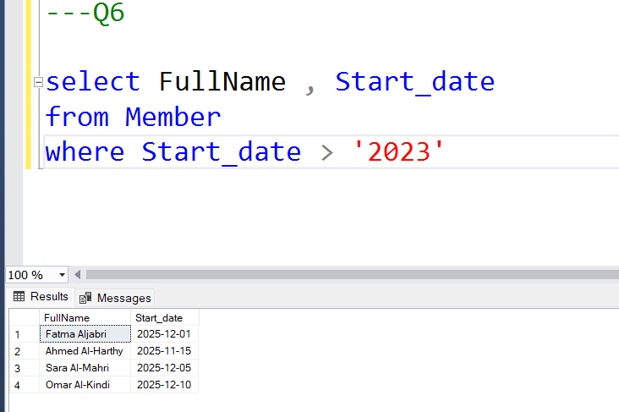

- SELECT Library_Name, Estableshed_year AS books_published
from Library
WHERE Estableshed_year > 2018

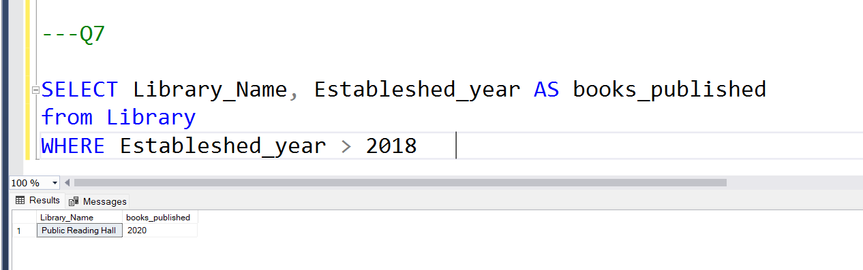

- select book_title , price
FROM Book
order by price desc

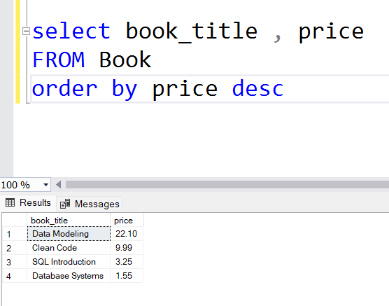

- select MAX(price), MIN(price), AVG(price) AS BookPrice
FROM Book

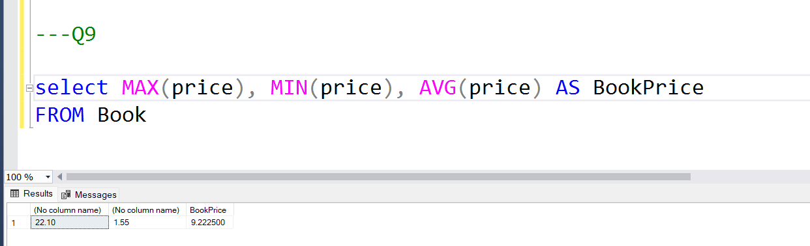

- select COUNT(*) AS Book_Number FROM Book

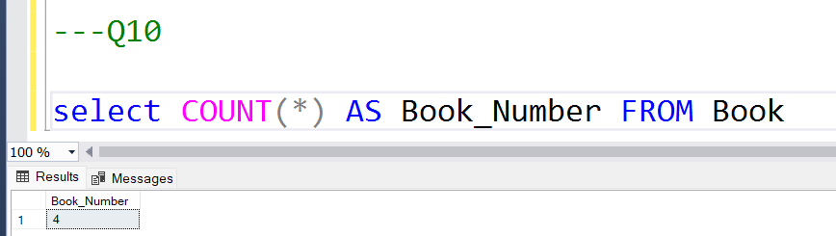

- select FullName , member_Email
FROM Member
WHERE member_Email is NULL

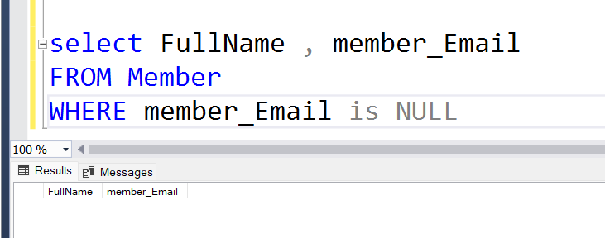

- select book_title
FROM Book
where book_title LIKE '%Data%'

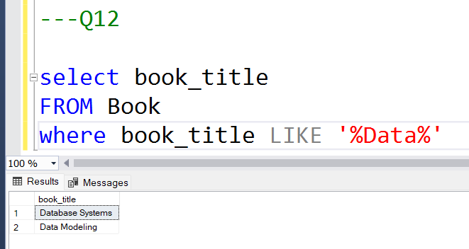

DML

Q1.
INSERT INTO Member(member_id,member_Email,Start_date,Mempership,loan_id,book_id,Phone_no) VALUES
(405,'Fatma Aljabri','fatma.aljabri@gimal.com', '1995-12-25', 'Regular', 301, 226 , '93397328')

Q2.

INSERT INTO Member(member_id,member_Email,Start_date,Mempership,loan_id,book_id,Phone_no)
VALUES (405,'Fatma Aljabri',NULL, '1995-12-25', 'Regular', 301, 226 , NULL)

Q3.
UPDATE Loan
SET return_date = GETDATE()

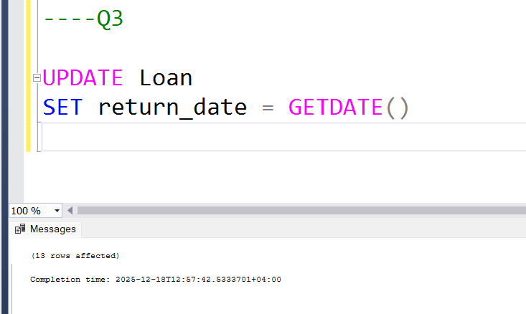

Q4.

UPDATE Book
SET price = price * 1.05
WHERE price < 200

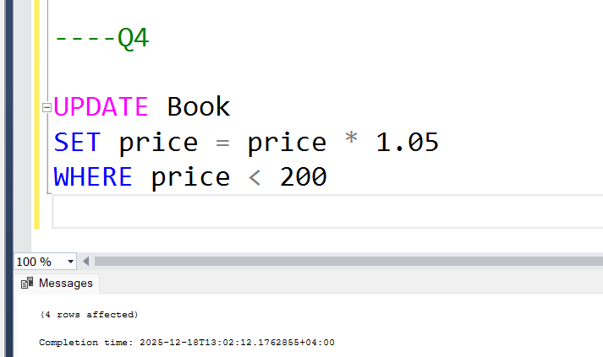

Q5.
SELECT FullName, Start_date
FROM Member
WHERE Start_date >= DATEADD(MONTH, -1, GETDATE());

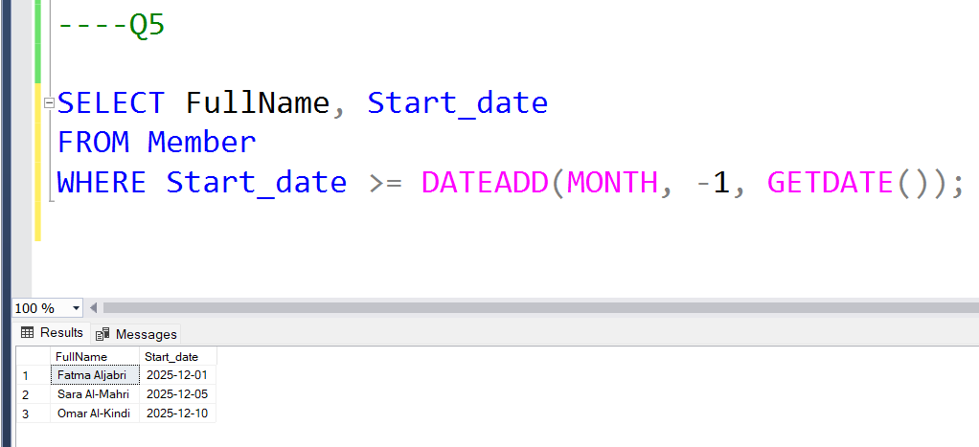

Q6.
DELETE FROM Member
WHERE loan_id IS NULL

